|  |
| --- |
| **STUDENT NAME** |
| Alley Chaggar |

**LAB #16**

BEFORE WE START 2

ACTIVITY 1 2

ACTIVITY 2 7

ACTIVITY 3 9

ACTIVITY 4 14

# BEFORE WE START

1. Double – click on the Blender icon on your desktop.
2. Close the tutorials windows.

# ACTIVITY 1

## CODING THE MOVEMENT

This tutorial demonstrates how to develop a script for moving and animate a 3D character in Unity. This tutorial requires a 3D, animated humanoid or generic character.

Follow the steps below:

1. Start Unity and open the 3D Character project from the Lab #16 Support Folder.
2. Right – Click under the Project tab.
3. Create 🡪 New Folder.
4. Name the new folder Scripts.
5. Right – click 🡪 Create 🡪 Script.
6. Right – click on the new script and Rename.
7. Name it PlayerController.
8. Open the script.
9. Copy and paste the below code in the PlayerController script:

|  |
| --- |
| **CODE** |
| using System.Collections;  using System.Collections.Generic;  using UnityEngine;  public class PlayerController : MonoBehaviour  {  float speed = 4.0f;  float rotSpeed = 80.0f;  float charRotation = 0.0f;  float charGravity = 8.0f;  Vector3 moveDir = Vector3.zero;  private CharacterController controller;  private Animator animator;  void Start()  {  controller = GetComponent<CharacterController>();  animator = GetComponent<Animator>();  }  void Update()  {  Movement();  GetInput();  DeadorAlive();  }  void Movement()  {  if (controller.isGrounded)  {  if (Input.GetKey(KeyCode.W))  {  animator.SetFloat("Speed", 1);  moveDir = new Vector3(-1, 0, 0);  moveDir *= speed;  moveDir = transform.TransformDirection(moveDir);  }  if (Input.GetKeyUp(KeyCode.W))  {  animator.SetFloat("Speed", 0);  moveDir = new Vector3(0, 0, 0);  }  }  charRotation += Input.GetAxis("Horizontal") * rotSpeed * Time.deltaTime;  transform.eulerAngles = new Vector3(0, charRotation, 0);  moveDir.y -= charGravity * Time.deltaTime;  controller.Move(moveDir * Time.deltaTime);  }  void GetInput()  {  if (controller.isGrounded)  {  if (Input.GetMouseButtonDown(0))  {  Attack();  }  else if (Input.GetMouseButtonUp(0))  {  StopAttack();  }  }  }  void DeadorAlive()  {  if (controller.isGrounded)  {  if (Input.GetKeyDown(KeyCode.F))  {  Death();  }  else  {  Alive();  }  }  }  void Attack()  {  animator.SetBool("Attack", true);  }  void StopAttack()  {  animator.SetBool("Attack", false);  }  void Death()  {  animator.SetBool("IsDead", true);  }  void Alive()  {  animator.SetBool("IsDead", false);  }  } |

1. Press Ctrl+S.
2. Switch to the Unity Editor.
3. Click on the Character under the Hierarchy.
4. Under the Inspector click Add Components.
5. Type PlayerController and select the newly created script.
6. Press Ctrl+S again.
7. Press the Start button.

Once you complete the previous steps:

|  |
| --- |
| **TASK 1.1:**  Compress this Unity project and add it to the submission folder. |
| upload iconIn the LMS, add the file to the assignment Lab #16 submission folder. You can submit multiple files at a time. |

# ACTIVITY 2

## WALKING PATH ANIMATION – GRAPH EDITOR

This tutorial demonstrates how to add a walking path to the animated character. We add a Bezier Curve and we add a Follow Path Constraint.

Follow the steps below:

1. Click File 🡪 Open.
2. Open the KidoBonesAnimatedBasicWalk.blend file.
3. Select the model and press Alt+G.
4. Click Add 🡪 Curves 🡪 Bezier.
5. Create path around the plane.
6. Click on the Armature of the character.
7. Click on the Constraints tab at the properties.
8. Select the Follow Path constraint.
9. Set the options as shown below:  
     
   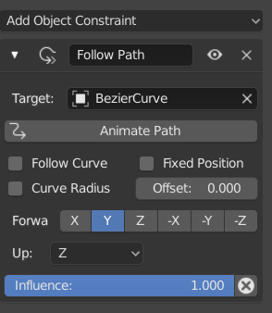
10. Press Animate Path.
11. For a Fixed Position animation, select the Fixed Position.
12. Set the Offset to 0.000.
13. Right – click and Insert Keyframe.
14. Set the Selector to Frame 60.
15. Set the Offset to 1.000 and right – click on the offset.
16. Click Insert Keyframe.
17. Now for the Graph Editor, select the Graph Editor panel.
18. Select the Armature and press the Home button on the keyboard.
19. Make all the other channels invisible and keep only the path.
20. Click on the Dot at the top of the curve and move it.  
      
    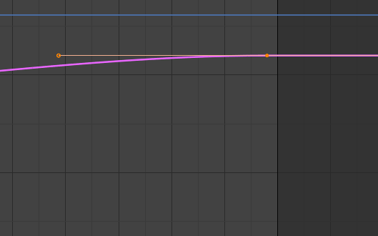
21. Click on the Graph at Frame 20.
22. Right – click on the Offset 🡪 Insert Keyframe.
23. Select the new keyframe and modify its curve as shown below:  
      
    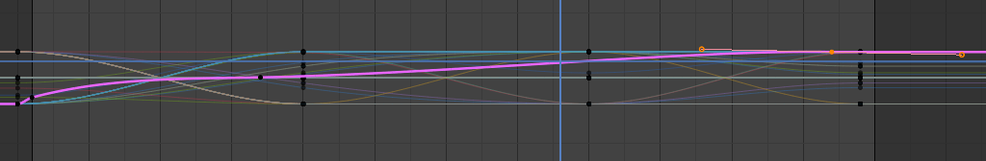

|  |
| --- |
| **TASK 2.1:**  In what speed the animation is shifted? Answer the question in the cell below. |
| The animation goes faster |

# ACTIVITY 3

## MATERIALS AND TEXTURES

The objects, we have rendered, so far, are mostly gray and colorless. A realistic 3D object, though, should be applied with at least one color or multiple colors. We can just apply a single color or wrap a picture over its surface (Texturing). Another addition could be the object’s Material. An axe has a wooden handle, but its head is made of iron or steel. This tutorial is a guide on how to use and apply Textures and Materials to 3D objects.

Follow the steps below:

1. Download the Axe.fbx and the image files from the Lab #16 Support Folder.
2. Store it to your computer.
3. Click File 🡪 New 🡪 General.
4. Click File 🡪 Import 🡪 FBX.
5. Click on the Axe.
6. Click on the Materials tab, under the properties.
7. Click New.
8. Click on the small circle next to the Base Color option.
9. Select the Image Texture option.
10. In the new menu click on the Open Image button.
11. Open the wooden_texture image file.
12. Name the new material Wood.
13. Select the Head of the axe, repeat steps 7 – 12, but name the Material, Iron.
14. Select the Decorations (middle and bottom), repeat steps 7 – 12, but name the Material, Gold.
15. If the Materials are not rendered, select the Look Dev Viewport View and rotate your point-of-view.
16. Click on the Shading tab.
17. Click on the Handle.
18. Click Shift+A 🡪 Vector 🡪 Displacement.
19. Connect the new node with the Output Material as shown below:  
      
    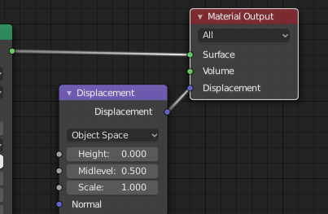
20. Then connect the Color from the wooden_texture.jpg node with the Height to the Displacement node, as shown below:  
      
    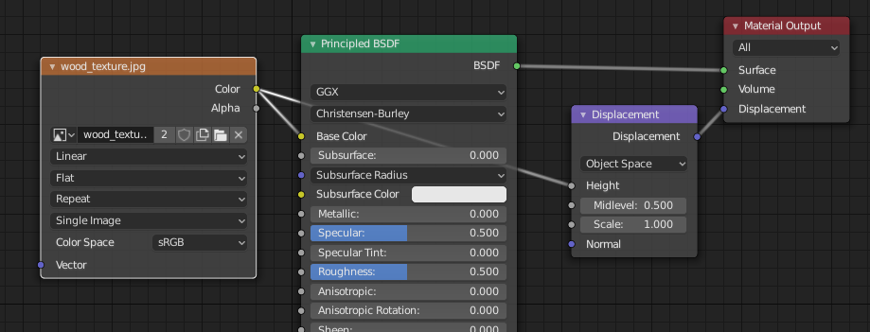
21. In the Displacement node set the Scale to 0.1.
22. In the Roughness option, under the Principled BSDF, set its value to 0.2.
23. Zoom in towards the handle.

Once you complete the previous steps:

|  |
| --- |
| **TASK 3.1:**  Take a screenshot of the Axe and paste it below: |
|    * This isn’t the axe it’s my own weapon for assignment 3! * I did the same process though |

1. Click on the Head.
2. Rename the current material to Head.
3. Click on the Open Image button.
4. Pick the concrete_floor.jpg image.
5. Set the Metallic value to 1.0 and the Roughness value to 0.2.
6. Click on the Shading tab.
7. Rename the current Material Smooth (if needed click on the Add Material Slot button).
8. Click on the New material button and name it Rough.
9. Make sure that the Head is selected.
10. Click on the image button next to the Open Image button, as shown below:  
      
    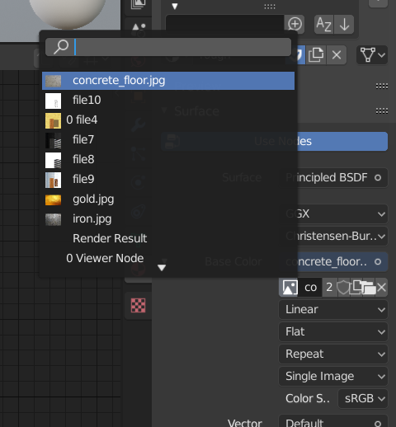
11. Select the concrete_floor image again.
12. Click on the panel, Shift-A 🡪 Vector 🡪 Displacement.
13. Connect the Displacement with the Displacement again.
14. Remove the line from the Base Color on the Principal Shader and connect to from the concrete_floor – Color to the Displacement – Height.
15. Under the Principal BSDF, click on the Base Color and set all the element, except of A, to 0 and the Metallic value to 0.
16. Turn to Edit Mode.
17. Select the front edge of the Axe, as shown below:  
      
    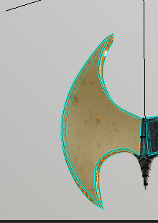
18. Click on the Smooth material from the list
19. Press Assign.

|  |
| --- |
| **TASK 3.2:**  Generate the Axe add it to the submission folder. |
| upload iconIn the LMS, add the file to the assignment Lab #16 submission folder. You can submit multiple files at a time. |

# ACTIVITY 4

## UV MAPPING

UV Mapping is the process of applying a texture (an image) over the surface of an object. Mapping is most efficient and easier way to apply vivid color to 3D objects. This tutorial demonstrates how to apply the correct colors and images on objects.

Follow the steps below:

1. Download the Bottle.fbx file from the Lab #16 Support File.
2. Open it on Blender and delete any other assets.
3. Be careful with the cap.
4. Click on the UV Editing tab.
5. In the Scene, switch to Edit mode.
6. Select the Edge Selection option and select the front, the back and the sides of the bottle, as highlighted to the images:  
     
   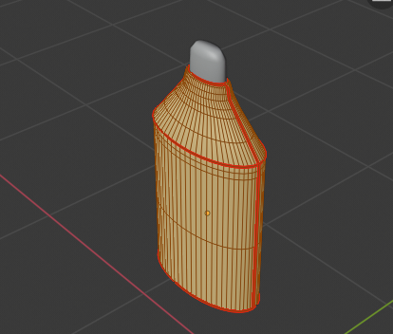  
     
   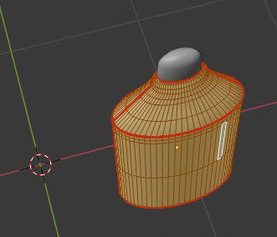  
     
   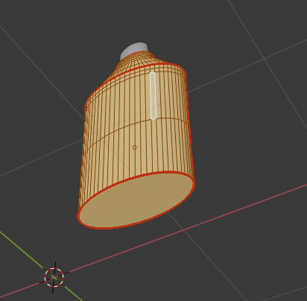
7. Press Ctrl+E 🡪 Mark Seam.
8. Select the Edge Select option.
9. Press A.
10. Press U 🡪 Unwrap.
11. Click on the UV Sync Selection button, as shown below:  
      
    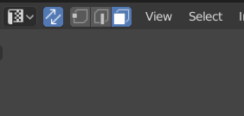
12. Select the object in the UV Editor and find the corresponding pieces on the object.
13. Position the UV map elements so that they have some order.
14. Keep in mind the front and the back of the bottle.
15. In the UV Editor, press A and then UV 🡪 Export UV Layout.
16. Save the file as BottleUVLayout.png.
17. Navigate to your file system, locate the file and right – click on it.
18. Click Edit with GIMP.
19. In GIMP, add a new Layer, make sure it is filled with transparency and name it Bottle.
20. Select the Bottle layer and draw as shown below:  
      
    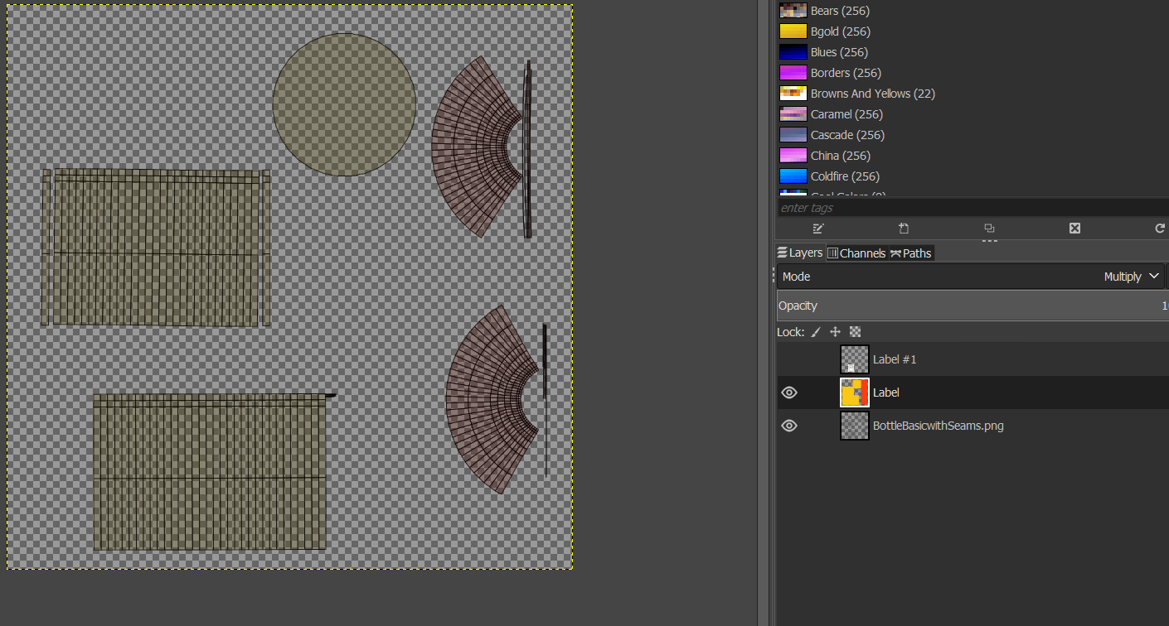  
      
    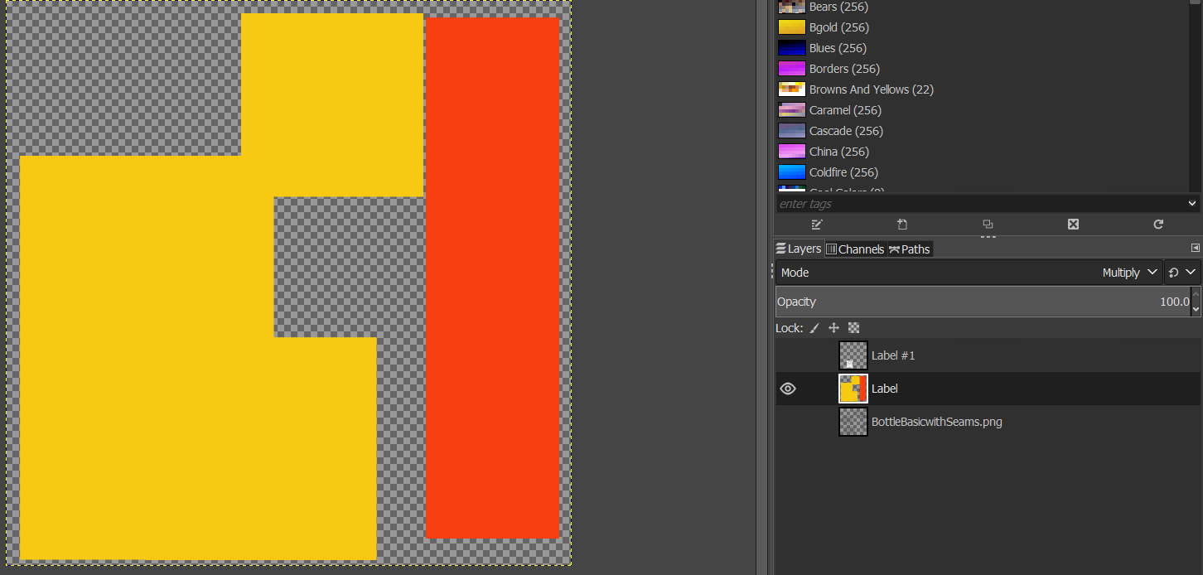
21. Cover the Lower sides and the bottom with a yellowish color and the upper sides with a reddish.
22. Enable the basic layout layer.
23. Download the Label.png file from the Lab #16 Support Folder and save it to your drive.
24. Click File 🡪 Open as Layers.
25. Scale to label to cover the front of the bottle.
26. Click File 🡪 Save as 🡪 BottleUVMapTemp.
27. Click File 🡪 Export as 🡪 BottleUVMap.png.
28. Switch to Blender.
29. Switch from the UV Editor to the Shader Editor.  
      
    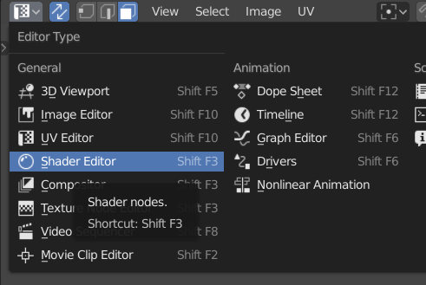
30. Click on the Material tab, under the Properties.
31. Click the path as shown below:  
      
    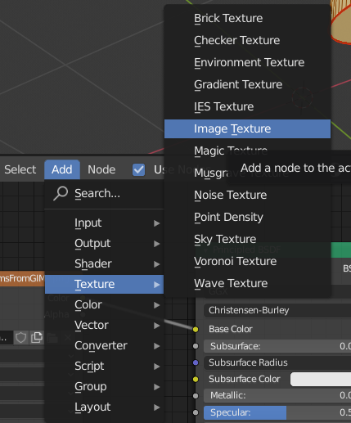
32. In the image texture click New.
33. Pick the BottleUVMap.png file.
34. Connect the Color attribute with the Base Color attribute of the Principled BSDF.
35. Switch to Texture Paint Mode.
36. The result should look like this.  
      
    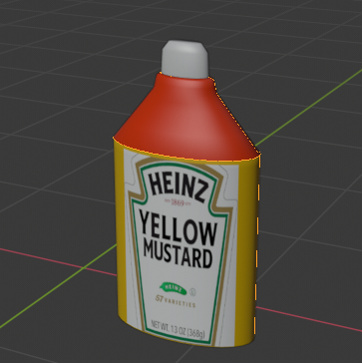

|  |
| --- |
| **TASK 4.1:**  Take a screenshot of the Bottle and paste it below: |
| * I used my own weapon for this part too! * I used the same process * I did some of my spikes on the weapon to be black   Chart, shape  Description automatically generatedA picture containing graphical user interface  Description automatically generated   * I moved the spikes to show |

1. Select the Cap.
2. Follow the steps 5 – 36, but select the cap.
3. Seam, Unwrap, Draw, Import.

|  |
| --- |
| **TASK 4.2:**  Take a screenshot of the Bottle and the Cap and paste it below: |
| * I don’t have a cap on my weapon….. |

1. Switch to Object Mode.
2. Select both the Objects.
3. Click File 🡪 Export 🡪 FBX.
4. Click the Selected Objects option.
5. Save pressing the Export FBX button.
6. Save the model as BottleUVMapFinal.fbx.

Once you complete the previous steps:

|  |
| --- |
| **TASK 4.3:**  Generate the BottleUVMapFinal.fbx file and add it to the submission folder. |
| upload iconIn the LMS, add the file to the assignment Lab #16 submission folder. You can submit multiple files at a time. |

|  |
| --- |
| ADVANCED Design and apply a UV map to your character from Labs #14 and #11. |

FINAL STEP: Save this document as a PDF. Upload the PDF to the Lab #16 submission folder.